|  |  |
| --- | --- |
| Lowepro StreetLine BP 250 Backpack  Balo Lowepro StreetLine BP 250  camera-backpacks-streetlinebp-250-left-sq-lp36946-pww camera-backpacks-streetlinebp-250-left-equip-sq-lp36946-pww camera-backpacks-streetlinebp-250-insertstuff2-sq-lp36946-pww camera-backpacks-streetlinebp-250-front-sq-lp36946-pww | **Featured information:**  Model: LP36946Material: Polyester & Nylon fabric  Dimensions: 33.5 x 13 x 52 cm  Compatible: 13 inch laptop  Weight: 1.1 kg  Price : $ 110  **Specifications:**  Model LP36946  External dimensions 13.2 x 5.1 x 20.5" / 33.5 x 13 x 52 cm  Dimensions in 12.8 x 4.7 x 20" / 32.5 x 12 x 50.8 cm  Polyester & Nylon material  Compatible with 13 inch Laptops  Weight 2.5 lb / 1.1 kg |

**Overview:**

Photographers who love a simple, functional and fashionable camera backpack will not be able to ignore the charcoal gray StreetLine BP 250 from LowePro. The versatile StreetLine BP 250 can accommodate a DSLR camera with standard lens, additional lenses, flash, related accessories, laptop and 13-inch tablet.

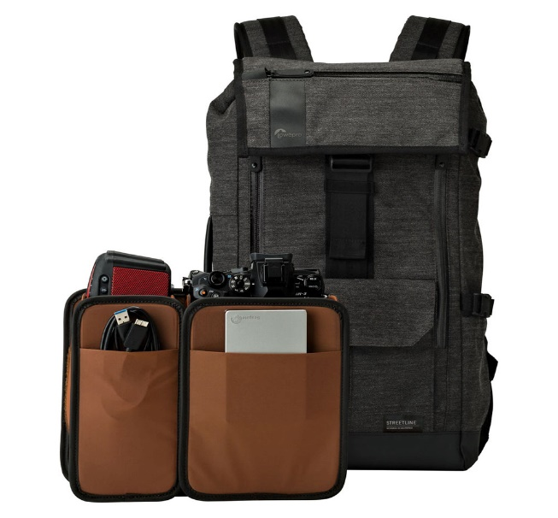

The large lid will protect the equipment inside the backpack from environmental factors. The lid has a sturdy lock with convenient opening and closing operations. The bag lid is designed with a zippered accessory compartment to store small items such as phones, keys, wallets, etc. Below the bag's lid is a small compartment with a lanyard, keyring and a hidden side compartment with a zipper suitable for documents or accessories.

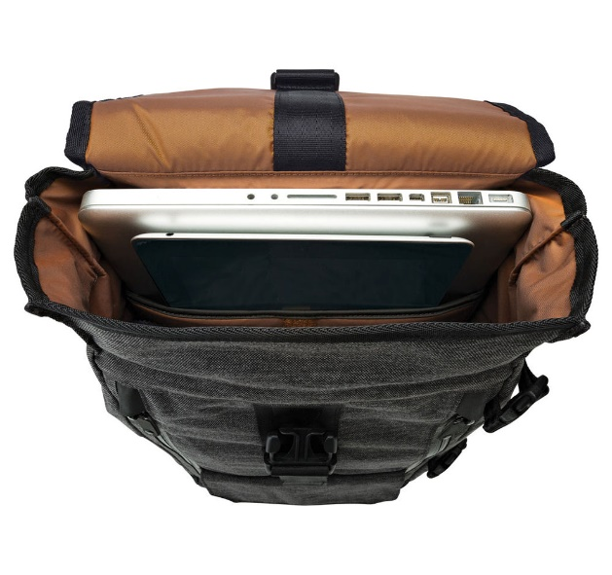

In addition, the StreetLine BP 250 also has a convenient removable bag that can be folded inside and can be expanded when needed to store and organize photography equipment or for use as a daily backpack.

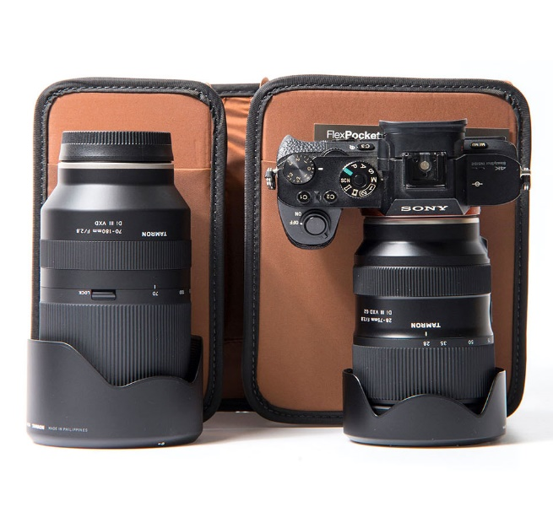

The StreetLine BP 250 backpack also has a convenient zipper designed on the side.